Tools for TroubleshootingTheory
1.List three real-life scenarios where a multimeter would be used to troubleshoot a computer or smartphone issue, and explain in one line how the multimeter helps in each case.

Three Real-Life Uses of a Multimeter
No. | Scenario | How the multimeter helps
1. | Computer power supply (SMPS) problem | Measures output voltage to check whether the SMPS is supplying the correct power.
2. | Smartphone not charging | Checks the charger’s output voltage and helps identify charging-related power issues.
3. | Laptop battery problem | Measures battery voltage to check whether the battery is supplying the expected voltage.
Conclusion: A multimeter is used to measure voltage, current, and resistance to troubleshoot electrical problems in computers and smartphones.
2.Watch a short YouTube video demo of a POST card in action (search for 'POST card motherboard test'), then write a brief summary (3-4 lines) describing what the POST card displays and what problem it helped identify in the video.<br><br><em><strong>Hint:</strong> Focus on the codes shown and how they relate to hardware issues.</em>

2. POST card demonstration and summary
A POST card (Power-On Self-Test card) is a hardware diagnostic tool used to troubleshoot a computer that fails to start properly. It connects to a compatible motherboard diagnostic interface, such as a supported PCI or LPC interface, and displays diagnostic codes during startup.
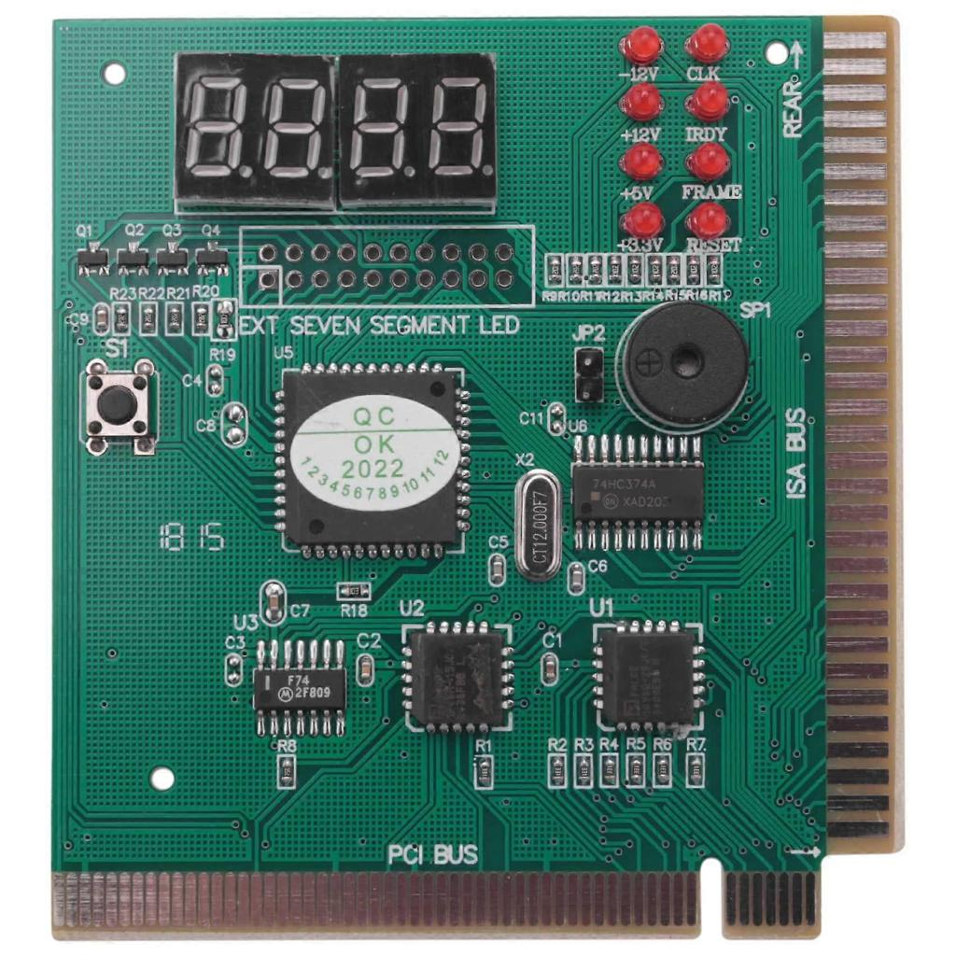
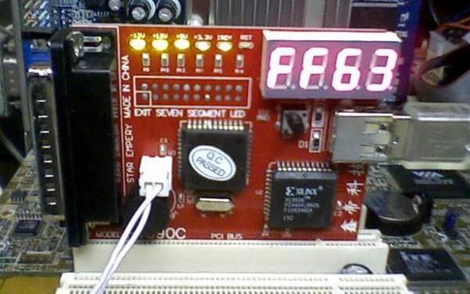
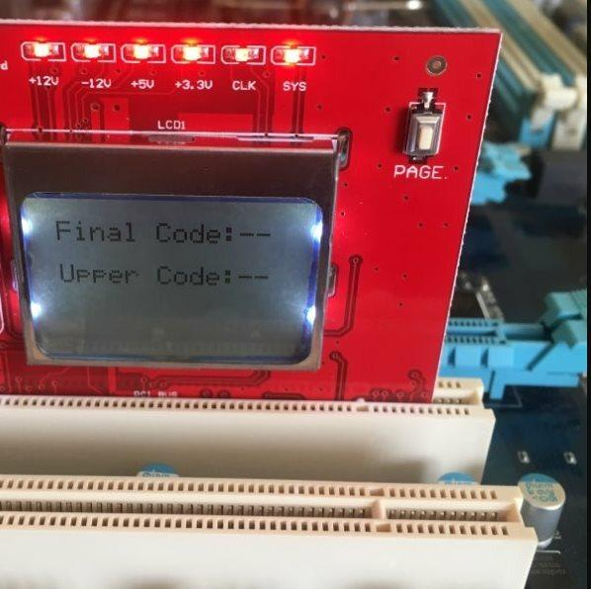
7
Assignment summary (3–4 lines)
A POST card displays hexadecimal diagnostic codes while the computer starts and performs its Power-On Self-Test (POST). These codes indicate the stage of startup and can help technicians locate hardware-related problems. For example, a code may help narrow down a fault involving RAM, CPU initialization, or another motherboard component. The exact meaning of each code depends on the motherboard BIOS and the POST card documentation.
YouTube video: Search for POST card motherboard test demonstrations
Note: The summary above explains typical POST card operation; it is not a verified summary of one specific video. To complete the video-specific part, watch a demonstration and record the actual code displayed and the fault identified in that video.
3.Download and install any free software diagnostic tool (such as HWMonitor, Speccy, or CrystalDiskInfo), run it on your laptop or desktop, and take a screenshot of the main dashboard showing system health details.<br><br><em><strong>Constraint:</strong> Blur or crop out any personal information before submitting.</em>

3. Install a software diagnostic tool and take a screenshot
For this practical, we will use CrystalDiskInfo, a free utility that checks the health status and temperature of a computer's HDD or SSD. It reads storage-drive S.M.A.R.T. information to help identify potential drive problems.

Crystal Dew World
+1
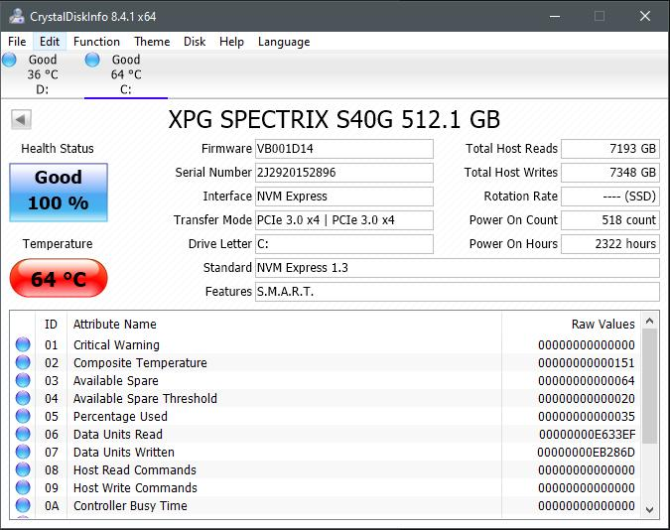
Step-by-step procedure
- Download the software: Open the official website: CrystalDiskInfo Download .
- Install the software: Select the Standard Edition installer, download it, and run the setup file. Follow the installation instructions.
- Open CrystalDiskInfo: Launch the application from the Start menu or desktop shortcut.
- Check system health: Observe the displayed drive model, health status, temperature, capacity, and available S.M.A.R.T. information.
- Take a screenshot: Press Win + Shift + S, select the application window, and save the screenshot.
- Protect personal information: Crop or blur any personal information before submitting the screenshot with your assignment.
What details should the screenshot show?
- Drive model and capacity
- Health status, such as Good, Caution, or Bad
- Drive temperature
- Available S.M.A.R.T. information
Practical observation: Write down the actual health status and temperature shown on your own laptop. Do not copy example readings or claim that the drive is healthy without checking it.
Result: CrystalDiskInfo was used to inspect the storage drive's health information and temperature.
Note: I cannot install the software or capture a screenshot from your laptop remotely. You must perform these steps on your device and attach your actual screenshot.
4.Compare the use of a multimeter, POST card, and software diagnostics by creating a table with three columns (Tool, What it checks, Example Problem Detected) and fill in at least one example for each tool.

4. Comparison of multimeter, POST card, and software diagnostics
These three tools help troubleshoot different types of computer problems. A multimeter tests electrical values, a POST card helps identify startup hardware faults, and software diagnostics monitor hardware information from within the operating system.
Tool | What it checks | Example problem detected
Multimeter | Voltage, current, and resistance in electrical circuits. | An SMPS output voltage is missing or outside the expected range.
POST card | BIOS/POST diagnostic codes during computer startup. | A startup code helps narrow down a RAM initialization or motherboard-related fault.
Software diagnostics | Drive health, temperature, hardware information, and other available system readings. | CrystalDiskInfo reports a storage drive health status of Caution.
Detailed explanation
1. Multimeter
- Used for electrical testing.
- Helps check power supplies, batteries, and electrical connections.
- Requires physical access to the circuit and correct measurement settings.
2. POST card
- Used when a computer fails to start or complete POST.
- Displays diagnostic codes that technicians interpret using the motherboard or BIOS documentation.
- Helps narrow down the possible faulty component; a code does not always prove that a particular component is defective.
3. Software diagnostics
- Run inside the operating system or through dedicated diagnostic environments.
- Show information such as temperatures, drive health, and hardware specifications.
- Are useful for monitoring and identifying possible faults, but cannot detect every hardware failure.
Conclusion
A multimeter is useful for checking electrical faults, a POST card is useful for investigating startup problems, and software diagnostics are useful for checking hardware health while the system is running. Using the appropriate tool helps technicians troubleshoot computer problems more systematically.

